13.51: a) From Eq. (13.43),
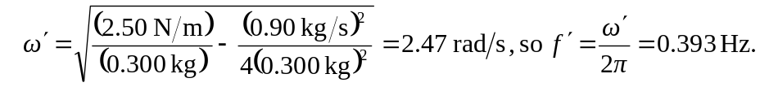
b)

